The Fairy Tale REVAMPED

Player's Manual

English

Table of Contents
Introduction 3
Getting Started 4
Windows 4
Manual Installation in Windows 4
Using the installer 6
Mac 6
Manual installation 6
Using the installer 7
The Game Jolt Client 7
Using the launcher 9
Screen Settings 9
New Game 11
Loading a game 13
Synchronize 14
Import and Export 14
Version Tab 14
The Game 15
Walking in the field 15
The Field Menu 17
Explanation of the character's statistics 19
Masters 20
Shopping 22
Combat 23
Main overview 23
Combat base menu 24
The Spirata transformation system 25
A few notes on the dynamic battle flow 25
The end of the battle 25

Introduction
Hello there, boys and girls.
Welcome to The Fairy Tale REVAMPED.

Years ago, I wrote the original Fairy Tale game. It was a great project at the time, however, a few things never came out right, so the finished game was never published as a result... Too bad. Still the story behind this game, child-friendly as it may seem, was the base of the Phantasar Chronicles novels that would appear later. With a friendly approach in the first novels (like Loni and Weniaria) at first, but a far more mature approach later (like The Madness Called “Love” and Irreversible).
It was a pity the Fairy Tale game never came out, and since this story was the story where it all began, I decided to “revamp” the game with the new stuff I have at my disposal now. With the help of my new LAURA II engine and the Kthura Map system it has, the game could come out so much better.

The story remained as much the same as possible, with only a few corrections, which were needed as the first game did not have a lore background rendering this game a bit incompatible with the lore in the way it's now, so this new version fixed all that.

Even though neither Jake nor Marrilona would ever have a major role in the novels, this story is part of the Phantasar lore now, and still the story where it all began, and somehow I do still love these two, and their deeds would be an important part in the history in the Phantasar lore.

I hope you will enjoy the story of Jake and Marrilona, as they fall in love while they were supposed to be enemies, waking up the Black Dragon in the process, getting them a responsibilities on their shoulders they are really too young to bear. Help them unfold the mysteries and secrets the world of Phantasar has been hiding for thousands of years.

Welcome to the world of Phantasar
Welcome to the world of Phantasar. This game shows you a portion of the rich history behind Phantasar. It has been a world of many humanoid races. The humans, fierce warriors who live in small communities, which are all nations on their own. The Fairies, who have a much bigger community spread over many cities, excelling in the ways of magic. The Dwarves, hard workers living in the barren lands in the North, and the Elves living in pure Harmony with nature. These are but four of the many populations living on Phantasar, but they will not play a part in this story, but they do in other stories.

Character profiles

Jake Daniël Werrington
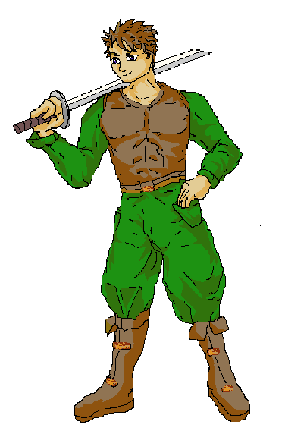
Jake is a young man, living in the village of Vandar. He's the son of the village chief and therefore the most obvious choice for to be the next chief. When the story begins Jake has just concluded his training as a warrior, and he was deemed a natural talent with the blade. He has a very honest and galant personality and is always the first to risk his own life for somebody else's.
Things get really hard on him when a magic love bond is formed between him and Marrilona forcing him to “betray” his own tribe. Yet Jake tries to make the best out of the situation, and he's willing to face every responsibility the love bond brought with it.
In combat Jake is your main fighter. Not as strong as Dandor, but more agile and versatile, especially after a little stunt Marrilona pulls on him.

Marrilona, daughter of Fandalora
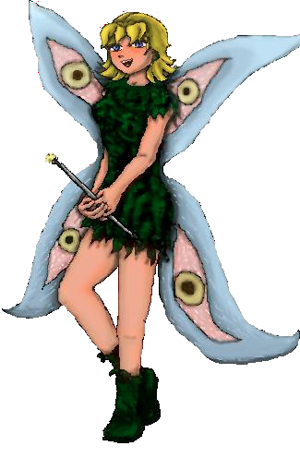
Marrilona is a young female Fairy who celebrates her 200th birthday at the beginning of the game. For Fairies you come of age when they are 200 years old, and from that moment a Fairy is considered an adult by the law. Marrilona has a very curious nature, also somewhat naïve and can be a little scatterbrained at times. She also has the bad habit to act first not thinking about the consequences, and thus she always gets herself in trouble. However Marrilona is also very honest, accepts the trouble, although with a few tears, and is always willing to clean the mess she created up herself. When she forms a magic love bond with Jake, she becomes very determined to let nothing ruin her party, but as you could expect, this will be the source of all trouble the story line revolves around.
In combat Marrilona excels in magic, and when you can find the enemy's weaknesses, she can be a vicious killer.

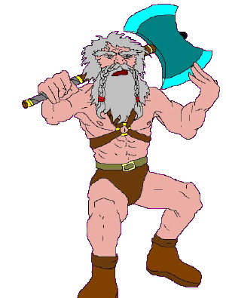
Dandor
Dandor is a Dwarf living on the Naked Rocks in the city of Grombo. He has a pretty straight-forward personality, and although he's a man of a few words, he does always speak his mind, and he hates nothing more than cowards, and makes no attempt at all to hide it.
In combat Dandor is very extremely slow, not very accurate, but he is very strong, and hard to kill. He will also be blessed with special protective powers which may work out pretty well in combat.

Hando Stillor
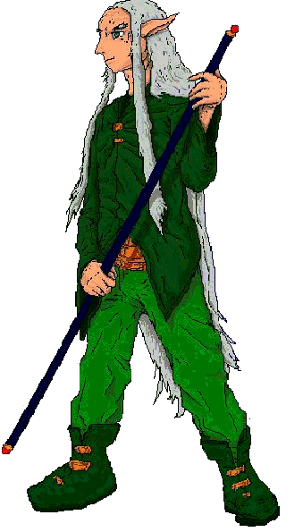
Hando Stillor is an Elfish High Priest in the order of Weniaria, the Goddess of Healing. He's very devoted to his Goddess and her teachings. Aside from serving his goddess he has a strong sense of duty in general and also a very strong sense of justice. He hates nothing more than the racial war dividing the four great races on his continent, while he is pretty sure there can only be benefit from uniting with the other races in stead of fighting them.
That is also why he sees the bond of love between Jake and Marrilona as a sign of hope that peace is possible, and that is why he decides to join them on their quest and to assist them to deal with the misery cast upon them.
In combat it will seem very obvious for a priest of Weniaria that he is your strongest healer. As an Elf he is also the quickest member of your group despite his extremely old age (which is even extreme for Elves who normally outlive humans by far).

Getting Started
Well the game is compatible with both Mac and Windows, but as the two systems differer entirely from each other I will cover both systems separately in this manual.
Installing the game through the Game Jolt client works the same on both systems, so that has its own section.
Strictly speaking the BlitzMax compiler does support Linux, which should make it possible to run the game in Linux, however, the support for Linux is pretty poor, so unless you are willing to help me on getting the Launcher and ht engine compiled in Linux, I won't be able to support Linux. The game should run in Wine though, although no official support will be given for that.

Windows

For Windows I'll limit myself to Windows 10, although the method in Windows 7 should be almost the same. I've never worked with Windows 8, and therefore no official support will be given for Windows 8.
There are two ways of installing the game in Windows. Through a “manual” install, and through using the installer. The installer will only be available for stable versions of the game, not for alpha or beta versions!

Manual Installation in Windows
The official distribution will always be in the .7z file format, unless you downloaded the game from a website which only supports or allows the .zip format. In order to unpack the .7z format you need the utility 7-zip. You can download this utility for free from http://www.7-zip.org
On the front page of the 7-zip website you can see this little menu:
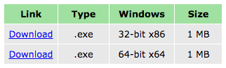
If you have a 64 bit processor you can of course best use the 2nd download link. If you don't know if your processor is 32 or 64 bit, just download the 32 bit as that version will always work, while the 64 bit version only works if you have a 64 bit processor. Since downloading works differently per browser I cannot do into the deep of that, but once the download is done use either the “look up” download feature in your browser or open the file explorer and look the downloaded file up. Open it, and the file will contain an installer allowing you to install the 7-zip application. Please follow the instructions of the installer.
The installer should automatically associate .7z files to the 7-zip utility now, so you can now just download the game and open the 7z file and you should see a screen similar to this.
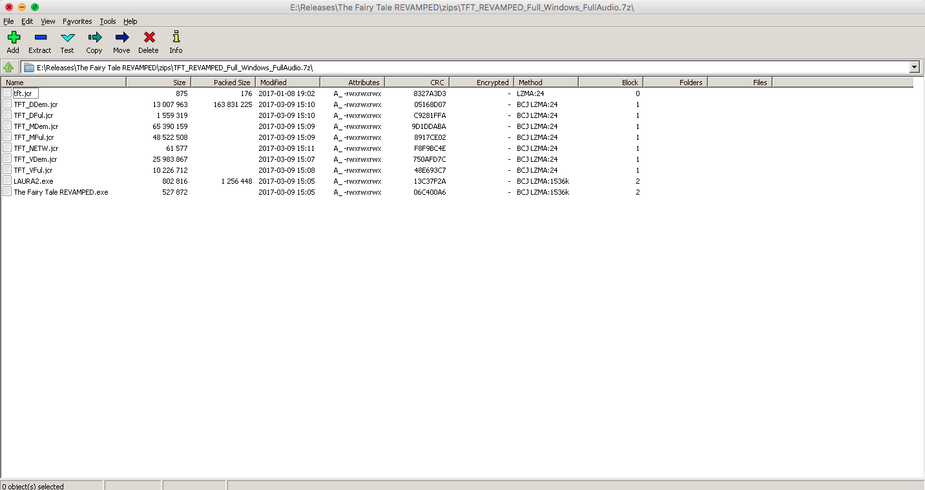
(Please note that I'm a mac user, so I ran 7zip using wine, and thus the mac window heading).
Also note, the files listed here, may differ based on the version you downloaded, but if you wanna make sure your file is correct:
- tft.jcr – Always present
- TFT_DDem.jcr – Always present
- TFT_DFul.jcr – Full version of the game only
- TFT_DMus.jcr – Not present in NoAudio version
- TFT_FMus.jcr – Only present in the Full version, but not in the NoAudio version
- TFT_NETW.jcr – Always present
- TFT_VDem.jcr – Not present in NoAudio version
- TFT_VFul.jcr - Only present in the Full version, but not in the NoAudio version
- LAURA2.exe – Always present
- The Fairy Tale REVAMPED.exe – Always present
(Please note, the sizes in this screenshot may be entirely different from what you will see, because this shot was taken when the game was still in development).
Now select all files and click the extract button. Now select the folder where you want the game to be installed and voilà!
Please note that this method will not create a Start Menu item or desktop icons or anything, so you will have to remember yourself where you installed the game.

Basically I only recommend this method to people who know what they are doing ;)

Using the installer
I must note that I'll only provide the installer for the STABLE versions of the game. So if you cannot find an installer anywhere, it means the game is still in either Alpha or Beta. I must impress that when you use a client program (such as the Game Jolt client or the itch.io client) to download this game to NEVER pick the installer, and only to use the installer when you are dealing with a “manual” download using a common web browser such as Firefox, Chrome or Opera.
The trick is is basically easy. Just download the installer and open it, follow the instructions in the installer and not only the game will be installed, but it will also be added to your start menu for quick access.
When you are not well versed in how to use file systems and such, the installer is the best way to go.
If you are also not well versed in using installers, then I recommend a friend who does know his/her business to install the game for you. The installer was made with InnoSetup, and must boys and girls who know their deal in Windows should be able to handle installers made with InnoSetup since it's a very well known installer creator (even for commercial programs).

Mac

Mac is well known for it's extremely user-friendly approach, and basically for the Fairy Tale REVAMPED that is no different, however a few things must be taken in order. Apple is also a bit “overprotective” over their users. (Read: They want to gain as much money as possible, and I don't pay approx €100 to Apple a year as a sign you can trust me. The Fairy Tale REVAMPED was a “no budget” project, after all). As a result the game will by default be blocked by the mac operating system (unless you set your security settings otherwise). Well there should be some ways to get around that. ;)

Manual installation
Well, the file you need will be provided in the .7z format. Most unpackers available for Mac should be able to handle that format nowadays, so I really expect no trouble for you here. Some sites may only support/allow .zip format, well if you downloaded the game from a site like that you have even less trouble since MacOS X/OS X/macOS or whatever you use supports that by default (why does Apple keep changing the name of their OS?).
So download the file and use either the browser's “look up in Finder” feature or look it up in the Finder yourself and double-click the downloaded file. Most unpackers for Mac will just unpack the file and create the application. Now drag the application to the the “Applications” folder (that is the English name of the folder, when your MacOS X system to configured to an other language the name may be different) and the game is installed.
But here's the rub, like I said Apple blocks all applications not downloaded through the Apple AppStore by default, so the first time you run the game, you must right click it and select “Open” and a kind of “mega-warning” will appear on the screen, wanting you to make sure you trust me. Just click the “Open” button and the game will run. In later playing sessions the OS should not bother you with this any more, and if it does, the method to “bypass” it, is just the same.

Using the installer
Since installers and applications are on Mac just folders containing tons of files, which you never notice, the installer is always provided either zipped or in a dmg file.
- If you have the zipped version, then download the zip, unpack its contents and right-click the installer and select “open” when the OS warns you.
- If you have the dmg then open the dmg file and it will be mounted as a disk-drive and you can open the installer from there. You should in that case also right-click it and select open when the OS warns you.
Well in both cases you can just follow the instructions inside the installer and the game should be installed in the Applications folder.
If you are not sure how to work with installers, well most Mac installers use the standard Mac install application for this, meaning all installers work with the same template. If you are still unsure, then you can always ask a friend to do it, but I don't expect much trouble.

The Game Jolt Client
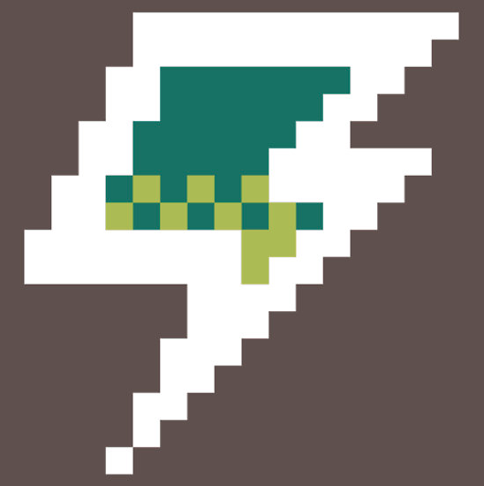
An easy way to install the game is, of course, the Game Jolt client, and it works the same for all platforms supported by the game.
The Game Jolt client can be downloaded from: http://gamejolt.com/client and is completely free to use. I must make myself clear though on one thing. I am not involved myself in the development of the client, and thus any trouble that may come your way that for which the client is to blame cannot be fixed by me, but for that you should contact the Game Jolt administration. Thank you.
The site explains how to download the installer and how to install the client itself. If the client shows a black screen with “nwjs.js” or something like that only, then something went wrong in the installation and then you just have to uninstall the client re-load it and install it again. It's a known problem, but nobody appears to know why this happens.
Now as far as I know the client DOES require a login. Game Jolt accounts are free, so it should be no trouble to create on on the site itself. If you are underage, please ask your parents for permission first before creating such an account.
Once you opened the client and logged in you can just use the search bar to look the game up.

On the page itself just pick the desired download and click the install button:
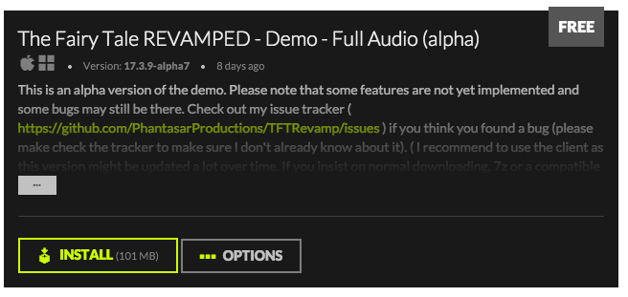
Now the game will be installed. You can now also use the client to run the game, though the same game page. The game will also be added to your library for quick access.

Using the launcher
When you run “The Fairy Tale REVAMPED” application you will not get directly in the game itself but the system will open the launcher first. The launcher collects some data the game needs to run properly. Don't you worry, by collecting data, I only mean some configuration the game itself needs, no data is sent over the internet (except, of course, the login data for the Game Jolt achievement API and Anna, but I suppose that's obvious).
Well the first tab is of course only a welcome tab, nothing special, I suppose. By selecting a different tabs you can get the game into action or configure it properly.
Let's discuss all tabs, shall we (all screenshots are from the Mac version. Although things look a slight bit different in Windows the workings are the same).

Screen Settings
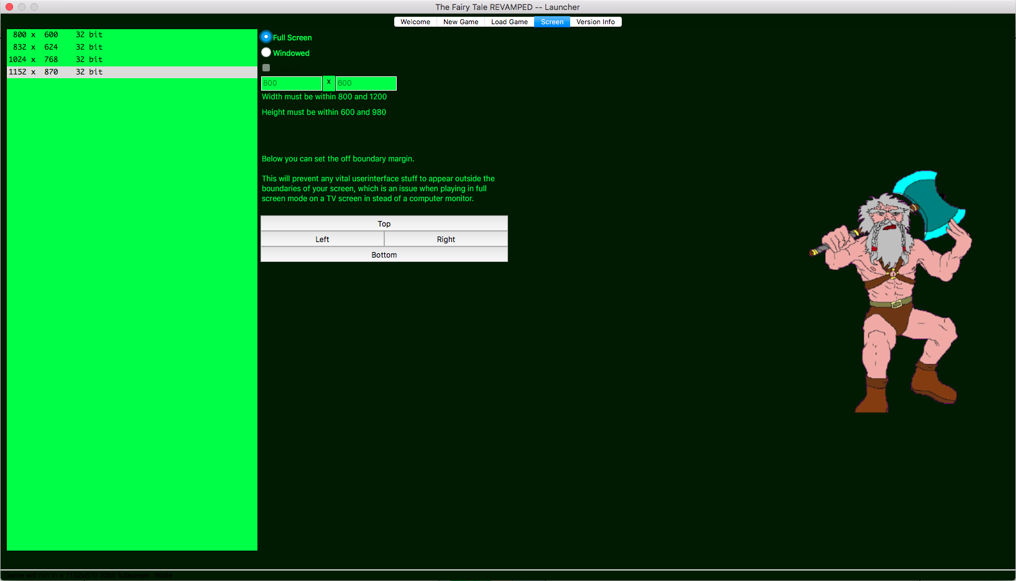
Before you do anything else I do recommend to mind the screen settings first. This game has been designed to adjust itself to different screen sizes, and why do you not want to take the fullest of of them?
The big area left shows all screen modes your computer supports in full screen mode that are within the margin of this game. More or less screen modes can therefore be displayed depending on what your computer (and monitor) support. Please note that if you have an older computer that higher resolution settings can slow the game down a bit. If you rather play Windowed then you can set the “Windowed” radio button. When you check the box below it you can in Windowed mode choose your own sizes, as Windowed game runs are not tied to your hardware settings, but keep in mind that if your monitor is too small to support whatever you enter, things can go a bit crazy.

Now I'm also quite sure that this may puzzle you:

Under normal circumstances I wouldn't bother these buttons, but some systems (and when you are connected to a TV in particular) some vital parts of the game may get outside the boundaries of the screen. Then you can set these and the game will place a little margin from the boundaries in order to keep everything ON the screen and not OUTSIDE of it.
If you want to experience this game like a “real” console game, these settings can be important.

These settings are store in a general config file, so if settings do not seem right and you already began a game, then by all means change them before loading your saved game file ;)

New Game
Well after you bugged a bit with the configuration, I guess the most logical step is to start a new game.
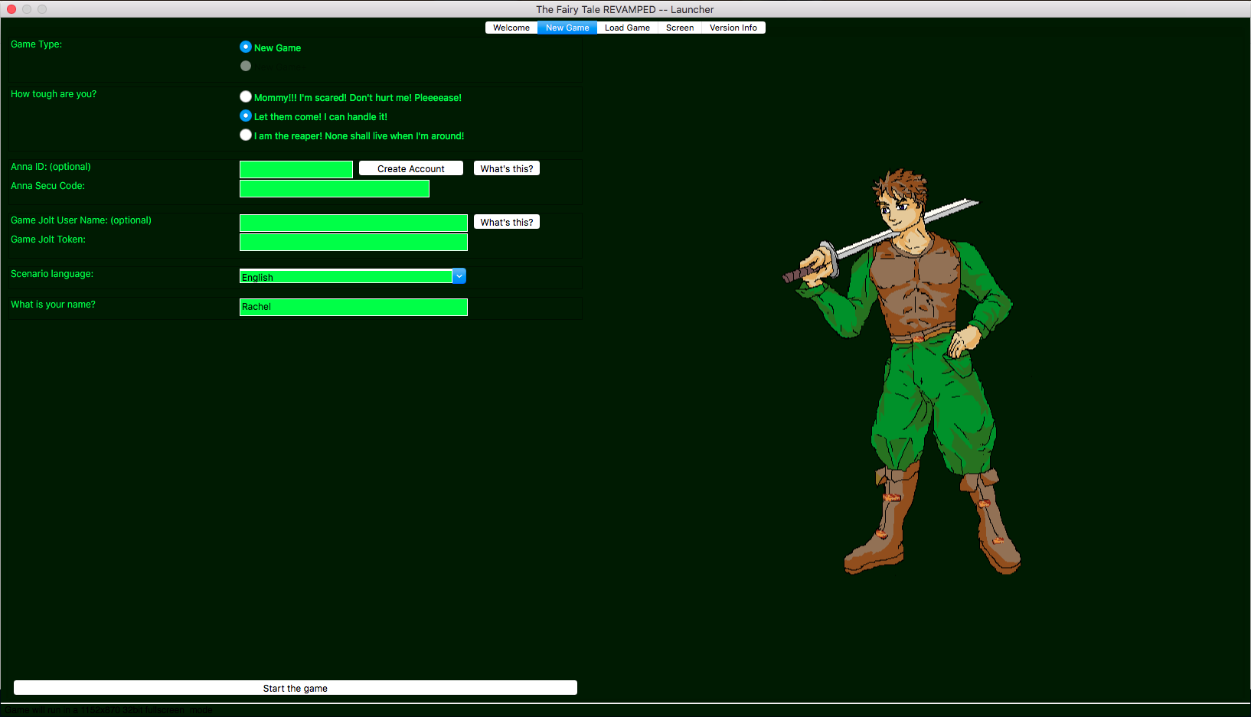
In this screen you can set up some base config.
WARNING! Once the game has begun these settings can NOT be changed, so make sure you set this all up well.

Let's explain all fields, shall we?
In the Game Type field you can choose if you want to play a “New Game” or a “New Game+”. In the New Game+ you will gain experience faster than in the normal game, and the game will even show a few things in the story line now shown in the New Game. In the New Game+ you may even be able to unlock 4 new secret dungeons, and one of them in particular can shine some extra light on the story line and most of all the main antagonist of the story. However the New Game+ is ONLY available if you completed a regular game at least ONCE. Sorry, folks :P

The “How Tough Are You?” field refers of course to the difficulty of the game. Please note this setting triggers more than just harder or easier enemies. There are a lot of significant rule changes in each setting that can really change your game experience. And that is why you can only set this now. The “Let them come, I can handle it” skill is the setting in which the game is intended to be played. In “Mommy! I'm scared! Don't hurt me! PLEASE!” the game has been heavily simplified on many points, and basically this setting should only be picked if you never played an RPG game before so you can learn the trade. Oh, well, if you only want to follow the story and don't want a challenge at all, I guess this setting will also do. When you pick “I'm the reaper! None shall live when I'm around”, the game will be very extremely hard. You may not notice that in the beginning, but trust me, you'll notice soon enough. Some though guys always complain RPG games are too easy. They play Final Fantasy X without using the sphere grid, or seek the hardest way to win a certain battle even when there are easier options and they know it. Are you one of those jackasses? Then this setting is for you. But be warned, if it's a hard game you'll want, it's a hard game you'll get! I've been pretty merciless in setting this mode up.
If you want more information about the difficulty settings please look it up in the specific section.

Who the hell is Anna?
Anna is a bot who can keep track of your achievements in games I wrote. She's been named after the Anna from the song “Boten Anna” by Basshunter, but unlike the Anna in that song, this Anna is a REAL bot. ;)
In most games Anna only keeps track of high scores and such, however in some game Anna may send you rewards based on how well you performed in all games supporting Anna altogether. Now it happens that The Fairy Tale REVAMPED is such a game. Once you reach chapter 2 it might be possible to visit Anna's Temple if your game is tied to Anna and in that temple you may get some rewards based on how impressed Anna is by your performances, not only in this game, but in other games tied to Anna as well.
The usage of Anna is optional, if you don't care about her, then simply ignore her, and she will ignore you. ;)

Game Jolt
And yes the game can log your achievements on the Game Jolt site too. If your game is tied to Anna and your Anna account is already tied to Game Jolt, you don't need to set these as then Anna will take care of this automatically. If you don't have an Anna account (and don't even want one) then you can set these up.
PLEASE NOTE! DO NOT ENTER YOUR PASSWORD HERE! ONLY YOUR TOKEN!
You can check your token on the Game Jolt site.
On the time this manual was written the game supported Dutch and English as scenario language. Please note, this will only affect the scenario. Item names, spell names system messages and so on will always remain in English. The system has been set up in a way easily allowing translation (as long as the roman alphabet is used, and yes the system has support for é è or ä, although tags are required for that).
The field at “your name” decides a folder for your savegames. Handy when you have multiple players on one computer playing the game on the same system account. The name that is imprinted by default is based on the user name set in your OS. So don't be frightened if you see your name appear there. I did not spy on you, the game simply reads out a setting from your OS, nothing more :)

Loading a game
Well in this tab you can load your savegames.
I guess it goes without saying that before you can use this feature you need to have saved one game first. And another important thing I need to note (before you think the launcher has crashed), the more savegame files you have the longer it takes for this tab to load, since it needs to analyze all savegame files, and the more files it needs to analyze, the more time it needs to get the job done. That sounds pretty obvious, but you'd be surprised how easily this stuff can go wrong.
Well, let's take a look at the load game tab shall we..
It should be pretty self-explaining, but, let's break it all down anyway, as it contains a few extra features which may need some extra explanation... maybe.
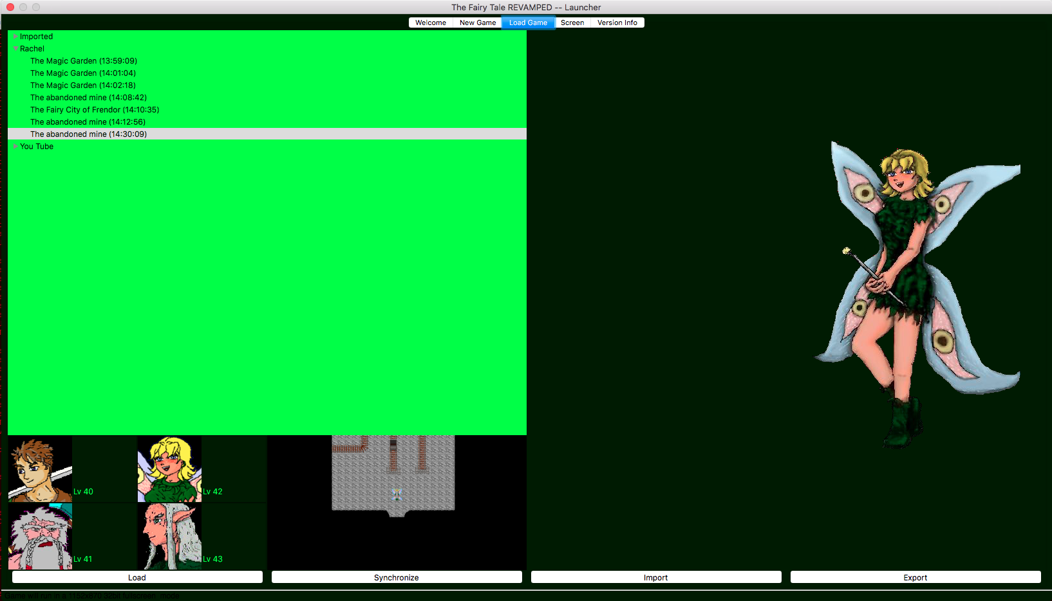
Well the big field on the left shows of course all the savegames, and as you can see per user folder too, which is based on the name you entered when starting a new game (with the exception of “Imported” but more about that one later).
The files show the location in which you saved the file, and the playing time, I guess that was obvious so far. In the diagram below you can see the characters who were in the party at the time with their respective level and a screenshot taken on the moment of saving.
If there's only one user folder, the launcher will not show the folders but only the savegame files inside that user folder in stead.
To load a game simply select the savegame files and click “Load” and everything should run.

Of course, I know you wonder what “Synchronize”, “Import” and “Export” do, well let's get into the deep of that.

Synchronize
If you want to play but either the Anna or the Game Jolt server is down or when you have an internet connection failure on your own accord, you can use this feature when all the trouble is fixed and everything will be synchronized with the respective servers in order to make sure your data is correct again.

Import and Export
Yeah, I know you want to to be able to share your savegame files with your friends. Come on, admit it. Everyone does. And this feature allows you to. Just pick the savegame file of your choice and select Export and you can put the file onto your USB stick or USB harddrive or put it in your cloud folder in order to get it automatically uploaded, well if you want to copy it into your iPhone or similar device, well I don't care how you wanna do it and with what, this feature allows you to. And once it's stored go with your device to your friend and on his machine you can use the “Import” feature and boom-tada.... the savegame will appear in the “Imported” folder.
A very important note though, your login data for Game Jolt and Anna will NOT be copied.
And if you are a Mac-user and your friend is a Windows-user (or vice versa), you can still use this feature as the savegame files are cross-platform. Yes, even if somebody could get the game running in Linux these savegame files should also be compatible with the Linux version.

Version Tab
The version tab only shows the versions of the Launcher, the LAURA II engine and the game data files. The game uses the “Ubuntu” version system in which the first digits show the year, the second set of digits the month and the third set of digits the day, and these are basically based on the time this wall all compiled or built or whachamacallit.
When reporting bugs, these version numbers can be important, as it might be possible you discovered bugs which were already fixed, but if your version happens to be outdated, you may never notice the fix.

The Game
Ah yeah, the moment we've all been waiting for. Explaining the game itself. Like any other game of this genre The Fairy Tale REVAMPED has some multiple screens, that may each need their own approach.
Let's get to it.

Walking in the field
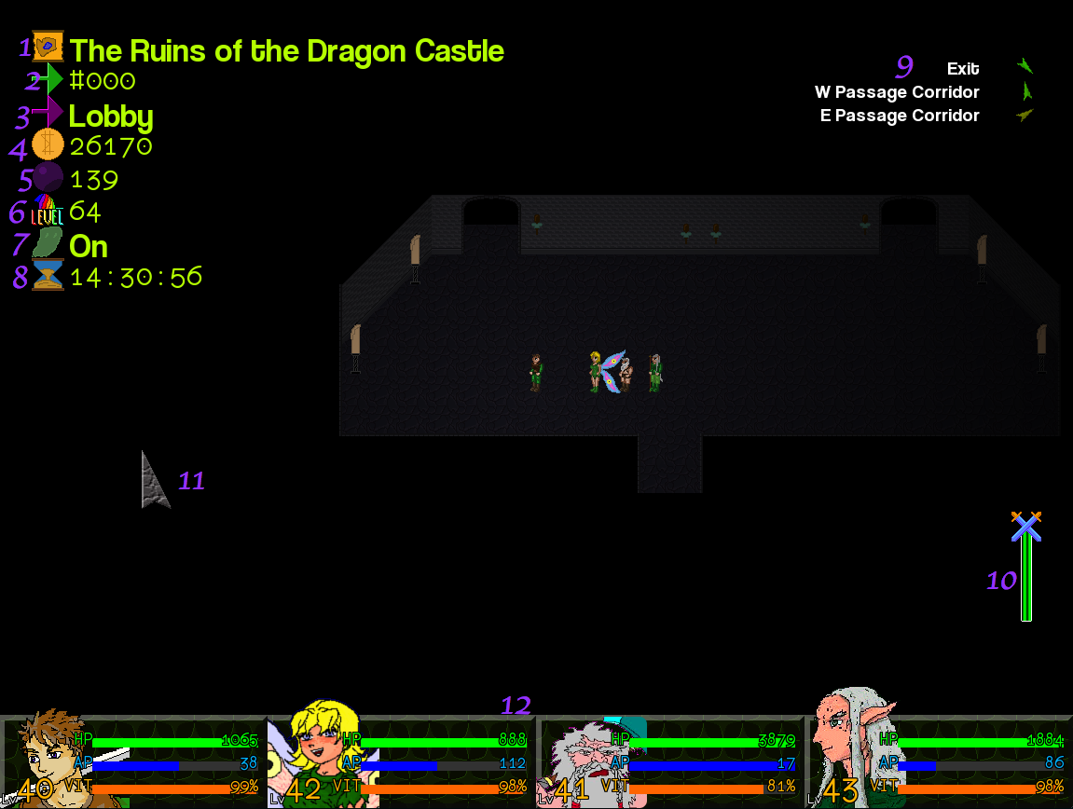
- The name of the current dungeon or town
- The current room number (these can be handy to look things up in walkthroughs)
- Name of the location (which is not always available)
- Your money in Shilders (the local currency).
- The number of black orbs you found. These are part of a sidequest.
- Current level cap, I shall explain more about that in the section about this.
- Random Encounters on off. I shall explain more about this in the specific section
- Play time. How much hours did you play the game?
- Compass spots, I shall explain more about that later
- Combat gauge
- Mouse pointer
- Character bar

Well, I don't think much of this stuff requires much information, but let's put a few things in order.
The field statistics (point 1-8) only appear if you do nothing for a few seconds. So don't panic I you're missing something. ;)
The room number, like I said will be referred to in the official walkthrough, but not only that, if a bug exists in a certain room only you can make my life a lot easier if you tell me the room number so I know where to be to fix stuff. This can save a loads of time.
The room name only appears if the room has one. In cities you may see them a lot, and in dungeons only in a few of them.
Well, the money seems clear to me, the number of shilders you have. Like in all RPG games you can use it to buy stuff and you'll get it if you sell stuff, and of course when you kill a monster you may be able to grab some cash. It can also be found in chests and stuff.
I won't tell much about the black orbs. If you really desire to know more, then check the walkthrough :P

Point 6 and 7 are part of the same system. And to explain this properly I must say that these cover two functions. First of all the game has a flexible level cap. Most RPG games have the levels capped at either level 50, 99 or 1000 (or a few extreme cases, like Disgaia at 9999), but the Fairy Tale goes into a different perspective. In the prologue missions you cannot gain experience at all, and when the “true game” starts, the initial level cap is only 4 in the normal difficulty setting. My... that's low, isn't it? But here's the rub.... All dungeons (including secret dungeons) except for disappearing dungeons and the prologue dungeons have a Traveler's Emblem either out in the open for you to pick or hidden somewhere in a secret passage. These emblems look like this:

Whenever you pick one up the level cap will increase. In a normal game in the casual difficulty that's an increase by 4 levels. In the difficulty settings section you can see how travel emblems fully affect this. And not only that, but if you find a dungeon's Travel Emblem you will also be able to turn the random encounters for that dungeon on or off for the remainder of the game. On the keyboard you can do that by pressing the “E” key. On the joypad that depends on how you configured your joypad.

The clock only shows how many minutes and hours you are now playing, it has no real in-game value, and there are no time-limits either.

The compass needles may also require some extra explanation. You may have figured they do not point North. They point to certain destinations you can find in the location you are in. In cities they can point towards the inn and the shops and such, and in Dungeons they mostly point to either the way forward or the way back, in some dungeons there can be multiple directions.
Very important to keep in mind is that the compass points “as the bird flies”. It does not point the way you have to walk, since obstacles walls or whatever are not taken into account, and neither are barriers which need to be removed first.

And on number 10 is the encounter gauge. It appears when you are in an area where random encounters are possible and it disappears when you are in an area where you won't meet any monsters (except maybe for bosses). The bar always starts in the color blue, and blue means you won't find any monsters at all. As you walk on the color will change to green (small chance to encounters), then yellow (big chance to encounters) and in the end it's red (encounter unavoidable). You will also notice that the bar goes down after each encounter. When there is no more bar left, you will not find any encounters here any more. Please note that the bar resets when you leave the dungeon or save your game.
When you turned the encounters off, you will still see this gauge, but it will be dark in order to indicate the encounters have been turned off.

Lastly let's discuss the character bar. It shows on nearly all screens of the game. It shows of course the characters who are currently in your team, and their Hit Points (HP), Ability Points (AP) and their Vitality (VIT). Now I guess you know what HP means, and AP are the points you need to use a special ability or to cast a magic spell. The Vitality points will refill your HP after combat, however, when you Vitality runs out you will not heal any more HP automatically, plus the more HP you lost during battle the more Vitality points will be consumed. Vitality points can be recovered when resting in an inn, and depending on your chosen difficulty setting they may pop back to 100% when you level up.

The controls are easy. You can either click where you want to go and the characters will go there. One of them is in the lead (mostly Jake) and the others just follow. If you click an object the party leader may use it, if you click a person, the party may talk to him or her. You can also use the keyboard to move around, and the game supports both the arrow keys as the WASD keys for this, and then you can press the spacebar to use stuff or to talk to people. On the joypad you can just use the directional controls of your controller and use the key you configured as the action key. Please note you can only move horizontally or vertically... not diagonally.

The Field Menu
The Field Menu can be “summoned” by pressing Tab on the keyboard, or by using the specific button on your joypad. With you mouse you can also click one of the characters on the character bar while walking in the field.
Now the menu may have a different setup than you may be used to see from most commercial RPG games, because I have chosen for a very quick and dynamic interface for this, but trust me, you'll get the hang of it very fast. (I don't work for Microsoft, you know).
First of all in the menu you have a selected feature and a selected character. You can select characters by either clicking them with the mouse, or by pressing the numbers 1 till 4 on the alphanummeric keyboard (the nummeric keyboard won't work, sorry).
The selected character determines whose statistics will show, whose spells or special abilities may show, and on whom items will be used if you try to do so.

And let's now discuss the menu features shall we. They are all on top op the screen, and you can use use the arrow keys, or the directional features of your gamepad, or click them with the mouse.

Let's discuss all features, shall we?

Full Statistics
This does, of course, show the base statistics, but they also show on other pages, but they also show your experience and level. I must note, experience counts backwards, so it doesn't show how much points you scored, but how much points you need to level up. It also shows your skill levels with their respective experience gauges. A full chapter will explain everything regarding statistics, leveling up and the skill system.

Items
Well, I suppose this is pretty obvious. With this feature you can see your current inventory. All characters use the same “backpack”, so regardless of the chosen character you always see the same items. If you use an item it will be used on the specific character if the item can be used. If you try to use a weapon, armor or jewel then the character will equip that item if he or she is able to. Please note that you may only carry a certain number of each item around. This cap is dependent on your chosen difficulty setting.

Special Abilities
Each character has his or her special abilities. Most of them are unique to this character and pretty much dependent on the racial traits of that character or the way this character was trained during the events prior to the game's story. I guess it comes to no surprise that Jake's abilities lies in the way of the sword, while Marrilona is as Final Fantasy fans would call it your black mage. Hando Stillor is high priest in the order of Weniaria, effectively the goddess of healing so I guess it goes without saying that he is what Final Fantasy fans would call your white mage. Well, we don't have a blue mage this time, sorry :P
What I need to note is that each character has multiple pages of abilities and on the keyboard you can use page up and page down to browse through them. The number of pages differ per character, and not to mention that Marrilona and Hando Stillor will in the demo only have their first page, and in the full version of the game you can gain access to the other pages. Page number 9 is always reserved for abilities masters teach you (see the master section for more information about that), and all other pages are dependent on your character. For the character's own abilities always goes that you will need to work out your skill experience to a certain level to obtain a new ability. Once that level has been reached and you try to perform a “normal attack” the character will show his/her own catchphrase on this phenomenon, perform the new move and it will be added to the list. All abilities you did not yet unlock can be found as “---” and if you hold the “H” key (or the key on your joypad for this function) you can see what levels are required and for what skill. However, it might be possible (for Jake, Marrilona and Dandor) the required level shows as “??”. In that case you do not have the required skill group yet, but you will very likely get it over time. Once you do those “??” will be replaced by the specific level requirement.

Masters
This page shows an overview of the masters you have, who their apprentices are and what they may teach you and what they require for that. You cannot change your master settings, this is only for a quick overview. Please read the master section for more information about masters.

Achievements
A full list of all attainable achievements (achievements containing spoilers are hidden though until the moment they are attained). These are the same achievements you can find on the Game Jolt site and on the Anna list. Even if you are not connected to either service, these achievements can still be attained, but of course they will only be logged to Anna and/or Game Jolt if you are logged in to those respective services.

Gamepad Configuration
If you are a gamepad/joypad user, it's very important you configure this well. You cannot rely on default settings, as they can differ greatly for each brand or model controller you can find on the market. A setting working for one brand may not work well for another. This is not a PlayStation on which I can assume everybody uses the same controller, and I had to keep in mind that not all gamepads are Mac compatible either. In basic it goes like this. If you OS is able to detect your joypad, so should the game, however your joypad MUST be connected prior to starting the game. If the game is running already when you connect your gamepad the game cannot detect it anymore. Any complaints on that can therefore not be handled.

Quit
OOOOOH! What does this button do?
When you select this feature you can just press “Y” and the game will quit, and possibly return you to the Launcher.
Mac Users may be able to make a quit-save here. Whenever you do the game will be saved, and when you go back to the launcher it will alert you to the existence of this quit-save. Loading it will resume the game where you quit it, however the file will be deleted as soon as the game is successfully loaded. Oh yeah, you whizkids, I know what you're thinking, just look up where this file is stored and rename/move it and load it then so we can keep it. Bad luck people, the file will be deleted anyway. I had taken that trick in mind when I set this stuff up.
The reason why the feature is not available in Windows is due to Windows refusing me access to some required features for this to run smoothly. That is a Windows issue, so complain to Microsoft about that, not me. Okay?

Explanation of the character's statistics
Hit Points (HP) | Go down when you are hurt. When it reaches 0 you'll be Koed.
Ability Points (AP) | Required to use special abilities. Goes up when you attack, get hurt or kill.
Vitality (VIT) | Consumed to recover HP after combat
Power | How strong will your physical attacks be?
Endurance | And how much defense do you have against physical attacks?
Intelligence | How strong will your magic attacks and healing spells be?
Resistance | And how much defense do you have against magic attacks?
Speed | Determines the order on the “card gauge” and also your “respawn” card spot.
Accuracy | Chances you hit the enemy
Evasion | Well if accuracy succeeds, maybe you can still dodge the attack.
Experience | Experience points you need to gain a level
Level | Your level
Master | Your current master

Masters
During your travels on Phantasar you will meet many people who do not care about the racial war, and who have loads to teach you. These people are called masters, and you can apprentice under them.
Doing so has its pros and its cons. Some of your statistics go up when you apprentice under a master while others might go down. This works in percentages of your base statistics (so the purse base stat, equipment and “buffs” and “debuffs” ignored). Don't underestimate these disadvantages. These stat changes will reset as soon as you dismiss a character from a master's service, and are thus not permanent.
The true power in choosing your master lies in the fact they have loads to teach you. Rubine, who is very likely the first master you'll find, is a skilled rogue and she can teach you how to pickpocket your enemies.
You do also need to take in mind that some masters may help you without any demands, but most of them have a set requirement you'll have to fulfill before they accept you as their pupil.
Each character can only study under one master at a time. If you apprentice a character under a master while he/she already has an other master he/she will automatically be dismissed from the other master's service.

Well as soon as you meet a master all you have to do is speak to him or her. If you fill his or her requirements he/she will automatically be added to the master list and you will get the screen showing what effect a master will have when you apprentice under him or her. Most masters will also show what they want you to do before they actually teach you new spells or abilities. When you fill the requirement for a new lesson, all you have to do is speak to this master again and he or she will teach you the ability you get as a reward for your hard work. This will also allow you to assign new pupils or to dismiss pupils from a master's service.
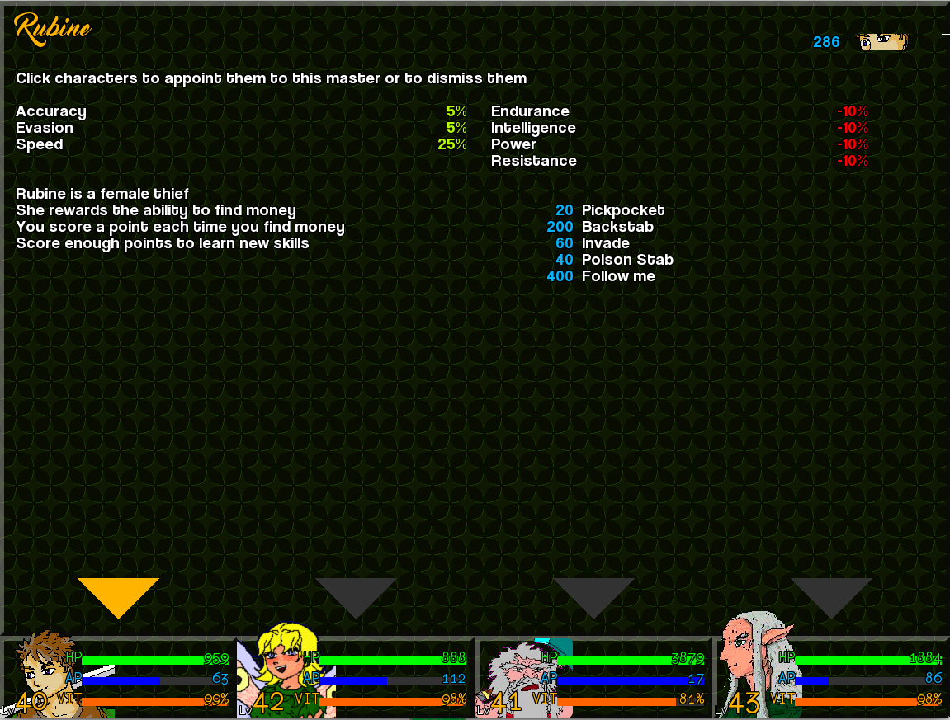
When looking at the master screen, a few things are important to take a look at. The stats on the left side of the screen are those that go up and on the right those that go down. On the upper right you can see Jake's eyes, because Jake was apprenticing under this master. The number shown is a score based on the requirements this master has set for learning a new ability,in Rubine's case that's the amount of time you found money while apprenticing under Rubine. You can also see all abilities she has to teach you, and the number in front of the ability is based on the requirement, in Rubine's case how much times you must have found money to get her to teach you a new move. The function behind these numbers and what shows at the apprentice's corner top-right can be different per master.
Also note that Dandor apprentice under all masters, but the magic based masters are mostly unable to actually teach him any spells. This is because the Dwarfish race has no magic powers at all.
The pointers on the bottom show also who is apprenticing and who is not. Simply click the character you want to assign to this master or to dismiss, or you can use the number keys on your keyboard.

Shopping
Like always you can shop to buy items or new equipment or to sell stuff you no longer need. It goes without saying that shopping requires money. The currency of the areas in this game is the “shilder”.
Also in this game I also chose a very fast to use interface for shopping, so be careful what you buy.
The shopping screen is divided in three tabs. “Buy”, “Sell” and “Trade”, although the “Trade” tab is only available if the merchant in question actually has weapons and/or armor in his or her stock.

Like it says, with this tab you can buy stuff. Just use the cursor keys to select the desired item. When you press the space bar you will buy it. When you want to buy 10 copies of the same items, simply press space bar 10 times. Of course you can also shop with the joypad and use the specified keys for this, and yes, you can also shop with the mouse.
Keep a good eye on your money, since you cannot buy anything when you run out of cash.

Selling stuff is of course also pretty self-explaining.
The game should only show those items which actually can be sold. Key items or items with a very special value in the game may not be sellable. Also note that you will get less money for selling than you would pay for buying, depending on the chosen difficult settings. Hey these merchants need to make a living, you know.

This tab is only available when a merchant actually sells weapons or armor. Using this feature will buy the requested item equip it automatically on the character this item is meant for, and will automatically sell the old. On screen you will see how much money will be left after the trade. The prices for both selling and buying will remain the same!!
If the character is equipped with an unsellable item, you cannot trade.

Combat

Main overview
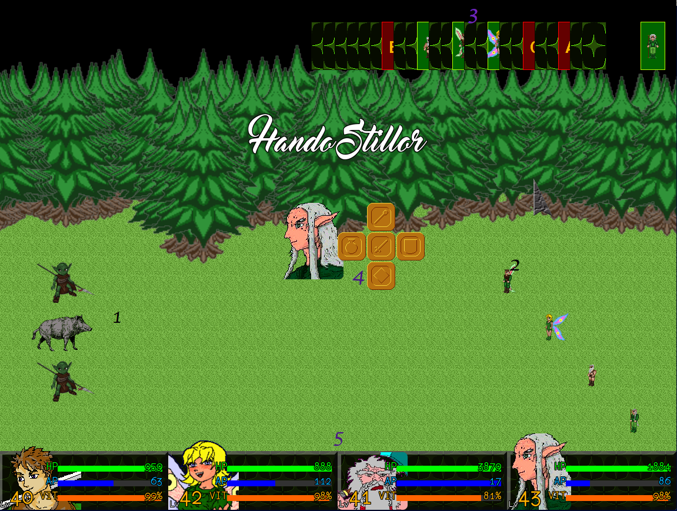
- The enemies
- Our Heroes
- The Card Guage
- Combat Menu
- Character bar

Well I guess I don't need to explain much about our heroes and the enemies. The card gauge however may need some work out. This gauge contains a special deck of cards and it shows a lot of neat information and using this information well can really work in your benefit. The card with their backside up are not in use at the present time. If they reach the action point nothing will happen and the game will go to the next card. Please note there are spells and abilities which can put something into these “empty card spots”, well more about that later. The green cards depict your heroes, and you may have guess it, when a hero card reaches the action point you may enter the move for this hero and he or she will immediately execute this move. The red cards are your enemies, and when an enemy card reaches the action spot the AI will enter a move for them, and they will also execute this move immediately.
Now here's the rub about this system. Some moves can remove cards from the gauge, oh to bad if that card was yours, and some moves can add extra cards on the gauge. Yeah, if you use a spell putting in 5 extra cards depicting Marrilona, it does indeed mean she has 5 extra turns. There is also another rub. Some spells add in ability cards, which show as blue cards. These blue cards can be both in your benefit as the enemy's and you never know whose card it is unless you pay proper attention. Whenever a blue card reaches the action bar the spell or ability tied to it will execute itself as long as the person who brought in that blue card is still able to fight. This will not cost extra AP. Making proper use of these kind of spells/abilities can really work in your favor. Beware though, some enemies (bosses in particular) can “take over” your cards turning your cards into theirs. Due to this each benefit has a risk. Be prepared for that.
Well the combat menu only appears on the moment you can actually enter a move. (I guess that was pretty obvious). The option-cross is a very common system. Just press space (or your gamepad's action button) to attack, or hold one of the arrow keys and press space to pick the action you want to perform in combat. If needed you will get into the next menus or be able to pick your target. When you prefer to play with the mouse you can also click the desired icon with the mouse.
Well the character bar is just the same as always, so no further explanation needed there.

Combat base menu
So let's go back to the the option-cross. What do all the icons in there actually do?

Attack
When picking this icon, your character will mostly perform a normal physical attack, however some weapons (like all of Marrilona's wands) can contain a special attacking ability on its own, and if your character is equipped with such a weapon that ability will be used in stead. For example if Marrilona is equipped with a flame wand she will use it to cast a fire spell on the enemy. If your character fulfills the requirements to unlock a new spell/ability, he or she will use that spell/ability in stead and add it to his/her ability list.
Special Ability
Harder attacks? Magic spells? It's all here. When you select this item, you will get a small window containing all the characters spells and abilities, and you can browser through them in the same manner as in the field menu. Yes, you can even see what you need to gain a new ability/spells. If needed the game will ask you to pick a target after selecting a spell.
Item
Use an item. The item picked will be consumed and you may pick a target if needed. Only the items you can actually use in battle will be shown.

Guard
The character will take a defensive state and nearly all attacks may do less damage as a result.

Spirata Form
Now this icon may require some extra explanation, so I will give it its own section below.

The Spirata transformation system
During the events of the game each character will merge him/herself with a Spirata. The Spirata are a kind of ancient god-line creatures and each of them representing a specific element.
- Jake will merge with the Fire Spirata, attaining the Spirata spell Fahrenheit
- Marrilona will merge with the Water Spirata attaining the Spirata spell Pascal
- Dandor will merge with the Earth Spirata attaining the Spirata spell Richter
- Hando Stillor will merge with the Wind Spirata attaining the spell Beaufort

Well when you select this feature, your character will consume all his or her AP and transform into a shape representing their merged form. In the next turn they will perform their Spirata spell, which represents the element of that specific Spirata, and the power of that Spirata spell can be very extremely strong or almost nothing depending on the percentage of AP the character had left on the moment of his or her transformation. So yeah 19/20 AP will do more damage than 25/200 AP. The character's base statistics do not matter, so even Dandor can perform a powerful magic attack here (and maybe this is the only way in which he can do so).

You can have the upper hand in battle when you use these Spirata transformations wisely. Also remember that your AP recovers when you attack an enemy (regardless if you hit it), when you guard and when any enemy gets itself killed in any way. Knowing that allows you to think ahead, as this game has been written to make you think on the longer term of things.

Of course using your transformations on a bad moment can cost you. Also keep in mind that if you transform, but all enemies are killed prior to performing the Spirata spell itself, all AP is just wasted.

A few notes on the dynamic battle flow
The battle flow is pretty dynamic. No annoying overviews after battle to click away, since you don't need them. So you can quickly go on as soon as you killed your enemies.
The experience killing an enemy gives is immediately given to your characters as soon as the enemy dies and is removed from the battlefield. And yeah, if that was enough experience to gain a level this will also happen instantly, even when the battle is not yet to an end.
Items are also dropped and taken immediately after an enemy dies. Yes, you can even use those items in the same battle immediately, if you need to. Money is also dropped immediately, but since you can't use your money in battle I guess that was pretty pointless, but hey, it's good to know, right.

The end of the battle
In most cases the battle ends when either you or your enemies are all KOed, or petrified. When the enemy has been knocked out you win the battle and the game continues. When your characters are all KO, then you may have a problem. Or not. When this happens in a random encounter, the party will be transported to the last inn you used and the game will continue. You may lose some money as a penalty though, so be prepared. If no inn is available or when you never used an inn, the game will be over. The same happens if you get killed by a boss. When the game is over you can just use the launcher to load a new savegame.

